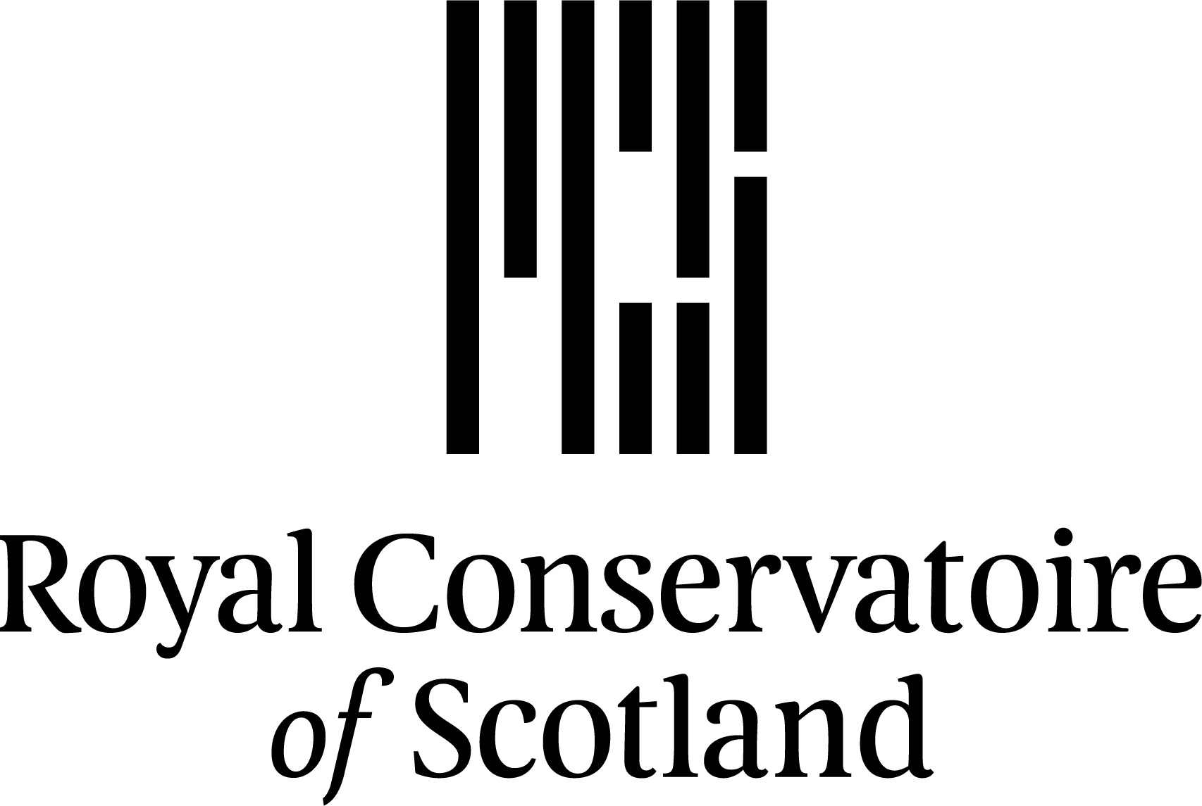

**BA Performance**

**(for Deaf and Hard of Hearing Actors)**

## Guide for Applicants: 2025/26

|  |  |
| --- | --- |
| CONTENTS | **PAGE NUMBER** |
|  |  |
| Introduction and Application Procedure | **3** |
|  |  |
| Entrance Requirements | **5** |
|  |  |
| BA Performance – Programme Information | **6** |
|  |  |
| Following your Audition | **7** |
|  |  |
| Students with Disabilities/Equal Opportunities Policy and Statement/Criminal Convictions | **10** |
|  |  |
|  |  |
|  |  |
|  |  |
|  |  |
|  |  |
|  |  |
|  |  |
|  |  |
|  |  |
|  |  |
|  |  |
|  |  |
|  |  |
|  |  |
|  |  |
|  |  |
|  |  |
|  |  |
|  |  |
|  |  |
|  |  |

**Introduction**

Thank you for your interest in the Royal Conservatoire of Scotland. If you require further information regarding the application and selection process or about your own application please contact Academic Administration and Support – Admissions.

Contact details are:

Tel: 0141 270 8265 (You can use Contact BSL Scotland to speak with our team: <https://contactscotland-bsl.org/contact-us/>)

E-mail: [hello@rcs.ac.uk](mailto:hello@rcs.ac.uk)

Website: [http://www.rcs.ac.uk](http://www.rsamd.ac.uk)

Please read this guide carefully before submitting your application and keep it for reference throughout the selection process.

#### Application Procedure

1. Application form and references
2. Record and send audition tasks
3. Live audition/interview (at RCS or online)

Applications are made directly to the Conservatoire. The application form can be e-mailed to you by our Admissions team, contactable at [hello@rcs.ac.uk](mailto:hello@rcs.ac.uk). Once submitted, you will be contacted by our Admissions team in due course about the proposed date of your audition.

## Closing date

The deadline for application form is **29.01.2025.** Late applications may be considered on a case-by-case basis by e-mailing [hello@rcs.ac.uk](mailto:hello@rcs.ac.uk).

### Audition/Interview period

Audition task videos should be sent by **28th February 2025**

Live auditions will take place in **March 2025.**

**Audition Location**

After we have watched your recorded audition tasks, we will invite you for a live audition/interview. These will be held at the Royal Conservatoire of Scotland. International applicants can audition online by agreement.

.

### Application Fees

There is no application fee.

**References**

You need to have two different referees to write references and make sure or tell them to send to the Conservatoire. **It is your responsibility to do this.** We cannot accept references from family, relatives or close friends. They could be a teacher or a director – someone who knows your work. The reference forms are part of the application form and can be found at the end of the Application Form document. Please send the forms to your referees to complete and return to RCS either via post: Admissions Office, RCS, 100 Renfrew Street, Glasgow, G2 3DB or via e-mail: [references@rcs.ac.uk](mailto:references@rcs.ac.uk).

**Tuition Fees and Funding**

Up to date information on tuition fees: ￼ <http://www.rcs.ac.uk/apply/finance/feesandfunding>

If you would like more information on fees or funding, please contact

[studentfinance@rcs.ac.uk](mailto:studentfinance@rcs.ac.uk)

**Scholarships**

If you are offered a place at the Conservatoire, you will be sent a financial statement form to complete. If you need financial support to take your place, The Royal Conservatoire of Scotland can offer a few entrance scholarships.

**Audition Preparation Courses**

The BA Performance team will be offering online/in person classes to help prepare you for your audition. Please contact [hello@rcs.ac.uk](mailto:hello@rcs.ac.uk) to find out more.

There are also short courses of different audition preparation throughout the year. For more information on these, please contact the team at [shortcourses@rcs.ac.uk](mailto:shortcourses@rcs.ac.uk).

**Entrance Requirements**

**General Entrance Requirements**

There are no formal academic entrance requirements for this programme. Applicants will be asked to:

* Share any relevant qualifications
* compose a personal statement explaining their background, motivation and experience. This can be in filmed BSL or written English
* Supply 2 references

All applicants must show auditioning panels that they have the **ability and potential** to cope with the demands of the course. Their progress, especially in the early stages of the course, will be closely monitored and appropriate advice and help given.

#### Language of Study

We welcome anyone who identifies as Deaf or Hard of Hearing. The languages of study are British Sign Language (BSL) or spoken English – your choice.

Deaf candidates with Sign Language other than BSL can and are encouraged to audition. You will be required to commit to learning British Sign Language should you be offered a place on the programme.

All applicants will be asked to state if their first language is BSL or English as part of the application.

As part of the audition process, we will evaluate your language levels in both BSL and/or English.

**BA Performance** (for Deaf and Hard of Hearing Actors) **–**

**Programme Information**

The **overall aim** of the Programme is to prepare you:

* + - to be an actor in theatre and TV/film
    - to devise, write, direct theatre and film projects (to make work)
    - to give you the knowledge, skills and qualities to make a sustainable career.

The BA Performance undergraduate degree teaches students to be both actors and makers of work, exploring the most innovative ways of creating performance through British Sign Language and English. During your three years here you will benefit from the distinctive environment of RCS and study a rich blend of performance modules.

This course is designed around the learning and teaching needs of deaf performers and is the only course of its kind in Europe. The programme has been developed in association with [Solar Bear Theatre Company](http://www.solarbear.org.uk/)with input from a range of theatre, education and deaf professionals. We aim to enrich the talent pool within the UK, whilst making training available to deaf artists.

The working languages of the programme are British Sign Language (BSL) and spoken English. There will be Communication Facilitators (Interpreters) in class and in rehearsal.

The small class size ensures you will have the opportunity to work closely with our teaching staff and visiting professionals. You will also benefit from our many collaborative and professional partnerships including Solar Bear, National Theatre of Scotland and Graeae Theatre Company. You will develop skills in acting, movement, dance, signing on stage, improvisation and puppetry as well as explore highly visual and physical performance styles. We will help you develop the skills you need to prepare you for a career in film, television, theatre and more.

We are looking for students who are very keen, willing to commit and able to show some good skills to a future career and who display potential and commitment to a career in the performance industry.

Through your unique vision and skills and the style of performance that you will develop, we hope you will not only make a living from acting and making work but will **influence the subject and style of performance.**

**Following Your Audition**

The outcome of your audition will be emailed at least 2 weeks after your audition date.

Please see below for an explanation to outcome decisions:

**Guaranteed Unconditional**

The Conservatoire is satisfied, from the information you have given, that you have already met the conditions for entry and wish to offer you a place at the Conservatoire.

**Guaranteed Conditional**

The Conservatoire has made the offer subject to you meeting certain conditions i.e. receipt of references. You must meet the conditions of the offer by the end of August in the year you aim to commence study.

**Reserve* Unconditional**

The Conservatoire is satisfied, from the information you have given, that you have met the conditions for entry and wish to offer you a place on the reserve list.

**Reserve* Conditional**

The Conservatoire has offered a place on its reserve list subject to you meeting certain conditions ie receipt of references.

**\*Reserve** – If you have received a reserve offer, it means that the Conservatoire is not able to offer you a guaranteed place at the time we make the offer. This is usually because the Conservatoire has already made or expects to make enough guaranteed offers to fill all available places on the course. A reserve offer is not a rejection. You will become part of a ‘pool’ of reserves. The Conservatoire may choose to make you a guaranteed offer if a suitable place becomes available. If the Conservatoire does not make you a guaranteed offer, you are not eligible to enrol at the Conservatoire.

**Unsuccessful**

We do not want to offer you any type of place

##### FEEDBACK TO APPLICANTS

1. Courses at the Royal Conservatoire of Scotland are very competitive and attract high numbers of applications. In line with the Data Protection and Freedom of Information Acts, the Conservatoire has put in place a process for the provision of feedback where possible.
2. Feedback requests must be made in writing to [feedback@rcs.ac.uk](mailto:feedback@rcs.ac.uk). The email must come from the address supplied on your application and must contain the applicant’s full name, course and date of birth.
3. Feedback requests will only be accepted from the applicant themselves. Requests from third parties will not be acknowledged.
4. Feedback requests must be received within 8 weeks after the audition/interview date. Requests received after 8 weeks will not be dealt with.
5. Feedback will usually take the form of a scanned copy of the audition decision sheet (assessment criteria). This will be emailed directly to the applicant. Feedback may take up to six weeks to process from the date of the request.
6. The Royal Conservatoire of Scotland will not enter into a dialogue with applicants regarding the provision of feedback. Our courses are highly competitive and applicants need to recognise that feedback may simply state the fact that other applicants were stronger or that the course is not, in our opinion, suitable for them.
7. Applicants should not consider the Royal Conservatoire of Scotland as arbiters of their ability. Feedback given is based on performance in the audition/interview and suitability for a particular course of study. Applicants who are unsuccessful in their application to us, may go on to gain places at other Conservatoires, and similarly, applicants whom we accept may have been unsuccessful elsewhere.
8. There may be occasions where an applicant considers that the Conservatoire has failed to meet its high standards in the consideration of their application. Disagreement with the academic judgement of the audition/interview panel in reaching their decision based on aspects of the applicant’s profile does not constitute grounds for a complaint by an applicant. Complaints will only be considered in relation to non-adherence to policy and procedure.
   1. Complaints can be made in person, by phone, in writing, by email at [complaint@rcs.ac.uk](mailto:complaint@rcs.ac.uk) or by completing our Complaints Form at [http//www.rcs.ac.uk/complaints](mailto:http@//www.rcs.ac.uk/complaints).

8.2 The following information will be required when making a complaint –

* Your full name and address
* As much as you can about the complaint
* What has gone wrong
* How you would like the matter to be resolved

8.3 Normally, you must make your complaint within six months of:

* The event/issue you want to complain about
* Finding out that you have a reason to complain

In exceptional circumstances, we may be able to accept a complaint after the time limit. If you feel that the time limit should not apply to your complaint, please tell us why.

* 1. We will give you our decision in five working days or less. Should the complaint need to be investigated, a full response to the complaint will be given to you within 20 working days. If the investigation is likely to take longer, you will be informed.
  2. Please refer to the Complaints Handling Procedure Guide for more information - <http://www.rcs.ac.uk/about_us/complaints/>.

**Students with Disabilities**

The admissions process take place in the context of the Conservatoire’s Equal Opportunity Policy, the Disability Policy and the Contextualised Admissions Policy. All applicants who have disclosed a disability will receive a copy of the Conservatoire’s booklet ‘Information for Students with Disabilities’. This can also be downloaded from the Conservatoire website - <https://www.rcs.ac.uk/studyhere/studentsupport/disabilities/>. Applicants with a disability are invited to contact the Counsellor and Disability to discuss their specific requirements, which may include special arrangements for the audition/interview. The Counsellor and Disability Advisor will, as a matter of course, write to all applicants who declare a disability on their application, and will provide information about applying to and studying at the Conservatoire. The Counsellor and Disability Advisor is also available to meet applicants when they come for audition/interview to discuss their particular requirements, sources of further information and any special funding that might be available.

### Equal Opportunities Policy and Statement

The Royal Conservatoire of Scotland welcomes a diverse population of students and staff. We believe that excellence can be achieved through recognising and celebrating the value of every individual. We are committed to promoting the equality in all of our activities and aim to provide a vibrant performing, learning, teaching, working and research environment that respects the diversity of students and staff, enabling them to achieve their full potential, contribute fully and to derive maximum benefit and enjoyment from their involvement in the life of the Conservatoire and beyond.

We are committed to equality of opportunity both as an education institution and as an employer. Equality of opportunity means striving to ensure that no student or member of staff receives less favourable treatment on the grounds of age, disability, gender reassignment, marriage and civil partnership, pregnancy and maternity, race, actual or perceived religion or belief, sex and actual or perceived sexual orientation.

**Guidance for Applicants with Criminal Convictions**

The Conservatoire believes that an unspent criminal conviction should not automatically prevent an individual from studying at the Royal Conservatoire of Scotland. Disclosing a criminal conviction is not a requirement of an application to study at the Conservatoire and applicants will only ever be assessed on their application, audition/interview and suitability for the course. The exceptions to this are below:

1. Students who are required to join the Protection of Vulnerable Groups (PVG) Scheme due to the nature of their course.
2. Students who are required to join the Protection of Vulnerable Groups (PVG) Scheme or require an Enhanced Disclosure Check due to the nature of certain option modules.
3. Student who require a visa to study in the UK who are required to disclose this information as part of the visa application process.

Though there is no need to declare a conviction as part of your application, applicants currently on licence are expected to make us aware of any conditions which may prevent them from fully engaging with their course and broader Conservatoire community. This is particularly pertinent when considering applying for a place in RCS accommodation. Where possible the Conservatoire will undertake to make reasonable adjustments where available.

The Conservatoire is able to give specialist advice and support for student entering our community from many different backgrounds. Students coming to the Conservatoire with a spent or unspent conviction may find it useful to connect with these services and gain additional support with studying at the Conservatoire. Disclosing convictions in order to utilise a service (e.g. financial advice) is dealt with confidentially and you will only be asked for enough information required to provide the service you require.

If you would like further information on the range of services, or to confidentially discuss a licence condition which you believe may prevent you from fully engaging with a course/taking a place in RCS accommodation, please contact Susan Lee Kidd ([s.leekidd@rcs.ac.uk](mailto:s.leekidd@rcs.ac.uk)) in the first instance. Please visit our website for further information: <https://www.rcs.ac.uk/wp-content/uploads/2014/04/Guidance-for-Applicants-with-Criminal-Convictions.pdf>.

**PVG Scheme and Enhanced Disclosure Checks**

Due to the nature of some courses and modules at the Conservatoire, you may be asked to join the Protection of Vulnerable Groups (PVG) Scheme or complete an Enhanced Disclosure check. This means that checks are carried out for any unspent and spent convictions and cautions. The checks also include any non-conviction data held by the police that may be relevant to course/module.

Applications for the PVG Scheme membership and Enhanced Disclosure checks are processed and assessed by Disclosure Scotland which provides this service as a means of enhancing security, public safety and protecting the vulnerable in society.

The Royal Conservatoire of Scotland will administer students applying to be members of the PVG Scheme and who require an Enhanced Disclosure check in accordance with prevailing Disclosure Scotland requirements and related legislation e.g. the Data Protection Act. If you would like further details of the Disclosure Scotland process please visit their website at [www.disclosurescotland.co.uk](http://www.disclosurescotland.co.uk).

A member of staff from the Conservatoire will only contact you directly should any issues arise from your PVG scheme membership or Enhanced Disclosure check. Using the information received from your PVG scheme membership or Enhanced Disclosure check, a panel will risk assess any criminal convictions and cautions.

**Future Work**

Though your conviction should not prevent you from studying on your desired course (our policy is to assess your application based on your application, audition/interview and suitability for the course), it is important that applicants with criminal convictions are aware of possible issues with gaining employment in their desired field after graduation depending on the nature of the offence. Information on what offences may prevent a graduate from working in a particular role can be obtained from the relevant regulatory body. Examples of areas of employment in which a criminal conviction may affect job opportunities include social work, education, healthcare and finance. However, there are many different roles within these sectors and where a previous conviction may have an impact on your ability to work in one role, it may not have an impact on another within the same sector.