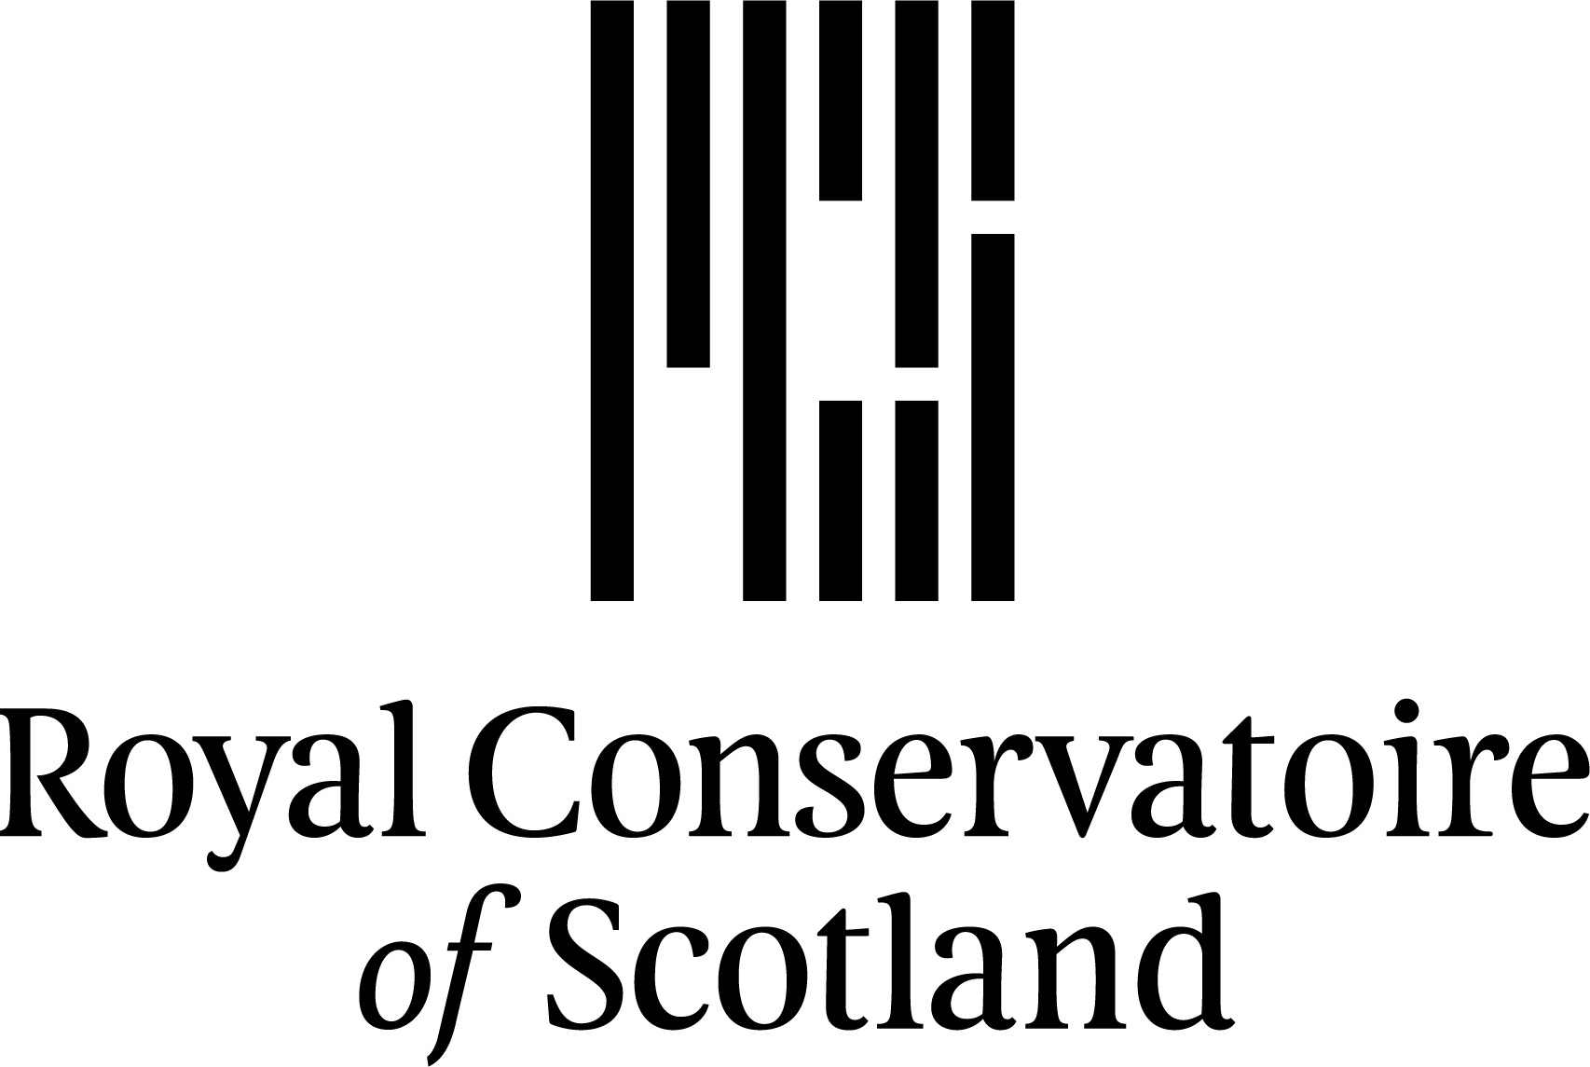

**BA Performance (for Deaf and HoH actors)**

The Audition Process

**Stage 1** – Application Form – complete the application form by 31st January 2025.

**Stage 2 – Audition Task videos**

The BA Performance programme trains you as a Performer but in two different ways: as Actor and as Maker. To see if you have potential to join and do well on the course, we would like to see how you work in these two areas.

Before you come to the building for your audition, we want you to prepare, rehearse, film and send us videos of **two tasks**:

**Acting Task (Monologue)**

Acting is about putting yourself in someone else’s situation and imagining what that is like and how you would behave. We want to see you do that. We want you to imagine that you are in a particular situation talking to another (imaginary) person/people for a particular reason. This is called a monologue. It is rehearsed and learned.

You have a choice about how you prepare:

Options (not all!):

We have supplied a few monologues. You can use one of these and if you use BSL, you can change the BSL if it doesn’t suit how you express yourself. Please see our document, **BA Performance - Scenarios and Monologues**, for further information.

There are lots of monologues printed in English. You can use any you like. If you are translating into BSL, we can support this. Get in touch with our Admissions team to organise some time with a lecturer in translation: [hello@rcs.ac.uk](mailto:hello@rcs.ac.uk)

**or**

Use a scenario to create your own monologue. You can use your own idea or one of ours. Think about a scenario where your character talks to someone else or needs to express something. What do they want to say? What do they want from the other person? Please see our document, **BA Performance - Scenarios and Monologues**, for further information.

Important things to remember:

* You can only prepare **one** monologue.
* Keep it short: 1-3 minutes is fine.
* Acting is about being honest: we want to see you behaving like a real person.
* Don’t feel like you have to be very different from yourself – we are interested in you!
* When you are imagining the situation, think about who you are talking to and why?

**Creative Task (Devising**

Devising is making a piece of performance from your own ideas. We want to see your ideas and how you communicate them in a theatrical way (not just talking!).

Your performance should be based on something important to you.

Your ideas can be from something you think about a lot.

The piece you perform could be:

A question that’s on your mind

related to social issues

personal experience

Don’t try to get it right or wrong: it should be something you want to communicate and share. The form of performance it takes is up to you.

It could be:

Visual Vernacular (a theatrical art form of physical expression, storytelling with strong sense of body movements, iconic signs, gestures, facial expressions)

Text-based

Movement

Visual Theatre

A song

Poetry

A mixture of some of these different styles

We are sending you links to a few videos that give examples of our graduates’ work. These are meant to help give you an idea of the kind of thing you could do. Don’t be put off by them and please do not copy these, but take inspiration!

'Long Lost Lover' by Bea Webster: [https://www.youtube.com/watch?v=gmgbLvm-neQ&feature=youtu.be](https://eur01.safelinks.protection.outlook.com/?url=https%3A%2F%2Fwww.youtube.com%2Fwatch%3Fv%3DgmgbLvm-neQ%26feature%3Dyoutu.be&data=02%7C01%7CK.Shields%40rcs.ac.uk%7C0c1b7740d9454f09b99008d8095cb6ce%7C09ab91a8e6d64fba98da63eac7ab3ce2%7C0%7C0%7C637269641252841517&sdata=Fyk2DgB6yy3d9upHqiP7eOQKLGIkWtr9DMUTE8Mm4uY%3D&reserved=0)

'Tsunami' by Petre Dobre: [https://www.youtube.com/watch?v=2RZSTzEWXXo](https://eur01.safelinks.protection.outlook.com/?url=https%3A%2F%2Fwww.youtube.com%2Fwatch%3Fv%3D2RZSTzEWXXo&data=04%7C01%7CK.Shields%40rcs.ac.uk%7Cba919b75e86a43e94dfb08d98e7b09f3%7C09ab91a8e6d64fba98da63eac7ab3ce2%7C0%7C0%7C637697481365343964%7CUnknown%7CTWFpbGZsb3d8eyJWIjoiMC4wLjAwMDAiLCJQIjoiV2luMzIiLCJBTiI6Ik1haWwiLCJXVCI6Mn0%3D%7C1000&sdata=tgUrBgA0py0P6yn0KHIhzwDIONfQgV9MBQL2xhpuqgY%3D&reserved=0)

Important things to remember:

* A short, rehearsed performance with content and form.
* It should be completely new.
* Don’t try and do what you think we want - be brave!

**Recap:**

We are asking for two short videos - one Acting, one Devising - that should last about 4-6 minutes in total.

When you have worked on both your pieces, have learned them and you are happy with your performance, record and upload them. To upload your videos, please created an account on Acceptd (<http://acceptd.com/rcs>) and upload your videos on to your account – feel free to also upload any supplementary information such as CV, resume, etc. These must be uploaded by the **28th February 2025.**

**Stage 3 – Recall Audition Day:**

When you have finished sending your audition recordings, you may be asked to a recall audition day. This will involve group workshops led by staff from the programme and an interview. We may ask you to perform your Acting/and or Devised piece (the piece you recorded) live and we might do it again with you. You will be given time to ask any questions about studying and life at the Conservatoire.

The Recall day will either take place in-person at the Conservatoire, or online should that be better for you dependent on location and/or preference. If successful, this recall will take place in **March/April 2025.**

____________

If you have any questions about the stages of the audition process, please don’t hesitate to contact our team at [hello@rcs.ac.uk](mailto:hello@rcs.ac.uk).