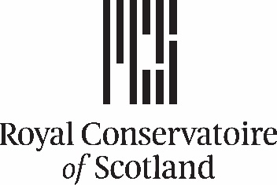

Athenaeum Awards Report Template – Projects

Please use the headings below to help you complete your reports. Please note that these reports will be used for internal audit purposes, as well as for internal and external communications.

A brief description of your project plus short biography and headshot (Circa 100 words, within two weeks of award funding) written in third person.

Interim report (Circa 300-500 words, within six months of award funding)
- a brief update on progress, including any changes to the original proposal
- any problems you have faced, and any assistance needed from the Research and Knowledge Exchange department
- expected completion date of the project

Full report (Circa 500-1000 words, within 12 months of award funding)
- a timeline for the project including details of what happened, where it happened, when it happened, project partners and collaborators, and if not already completed, expected completion date of the project
- any changes to the original proposal, including budget
- a final budget, including receipts for expenditure
- personal and professional benefits and impact as a result of the funding
- benefits and impact to RCS and to the wider field
- outputs including papers, presentations, performances, recordings, etc.
- any networking, new contacts or further work that have resulted from the project
- whether you have registered as a sole trader, business or partnership as a result of the project
- your next steps
- your plans for sharing your findings at RCS
- please include any relevant photos, videos, images, and recordings

Please return your reports to keadmin@rcs.ac.uk within the time frames shown above.

Please also remember to update your PURE profile!

Many thanks!

